
Artificial Intelligence
Assignment NO: 01

February 17, 2026
Muhammad Abduulah, Faseeh Cheema
23F-0698, 23F-0872

Question No: 07
Code:
import matplotlib
matplotlib.use("TkAgg")
import matplotlib.pyplot as plt
import numpy as np
from collections import deque
import heapq

ROWS, COLS = 15, 15
START, TARGET = (0, 0), (14, 14)
DELAY = 0.01

MOVES = [(-1, 0), (0, 1), (1, 0), (1, 1), (0, -1), (-1, -1)]

def create_grid():
grid = np.zeros((ROWS, COLS))

grid[5, 2:13] = 1
grid[10, 0:10] = 1
return grid

def draw(grid, frontier=None, explored=None, path=None, title="AI Pathfinder"):
plt.clf()
img = np.zeros((ROWS, COLS, 3)) + 0.9
img[grid == 1] = [0, 0, 0]

if explored:
for node in explored:
img[node[0], node[1]] = [0.6, 0.8, 1.0]

if frontier:
for node in frontier:

curr_node = node[1] if isinstance(node, tuple) and len(node) == 2 else node
if isinstance(curr_node, tuple):
img[curr_node[0], curr_node[1]] = [1.0, 0.7, 0.0]

if path:
for node in path:
img[node[0], node[1]] = [0.0, 1.0, 0.0]

img[START[0], START[1]] = [1.0, 0.0, 0.0]
img[TARGET[0], TARGET[1]] = [1.0, 1.0, 0.0]

plt.imshow(img)
plt.title(title)
plt.axis("off")
plt.pause(DELAY)

def reconstruct(parent, end_node):
path, curr = [], end_node
while curr is not None:
path.append(curr)
curr = parent.get(curr)
return path[::-1]

# --- 1. BFS ---
def bfs(grid):
q, parent, explored = deque([START]), {START: None}, []
while q:
curr = q.popleft()
if curr == TARGET: return reconstruct(parent, TARGET), explored
if curr not in explored:
explored.append(curr)
for dx, dy in MOVES:
nxt = (curr[0]+dx, curr[1]+dy)
if 0<=nxt[0]<ROWS and 0<=nxt[1]<COLS and grid[nxt]==0 and nxt not in parent:
parent[nxt] = curr
q.append(nxt)
draw(grid, frontier=list(q), explored=explored, title="BFS Running...")
return None, explored

# --- 2. DFS ---
def dfs(grid):
stack, parent, explored = [START], {START: None}, []
while stack:
curr = stack.pop()
if curr == TARGET: return reconstruct(parent, TARGET), explored
if curr not in explored:
explored.append(curr)
for dx, dy in reversed(MOVES):
nxt = (curr[0]+dx, curr[1]+dy)
if 0<=nxt[0]<ROWS and 0<=nxt[1]<COLS and grid[nxt]==0 and nxt not in parent:
parent[nxt] = curr
stack.append(nxt)
draw(grid, frontier=stack, explored=explored, title="DFS Running...")
return None, explored

# --- 3. UCS ---
def ucs(grid):
pq, parent, explored = [(0, START)], {START: None}, []
cost_so_far = {START: 0}
while pq:
curr_cost, curr = heapq.heappop(pq)
if curr == TARGET: return reconstruct(parent, TARGET), explored
if curr not in explored:
explored.append(curr)
for dx, dy in MOVES:
nxt = (curr[0]+dx, curr[1]+dy)
new_cost = curr_cost + 1
if 0<=nxt[0]<ROWS and 0<=nxt[1]<COLS and grid[nxt]==0:
if nxt not in cost_so_far or new_cost < cost_so_far[nxt]:
cost_so_far[nxt] = new_cost
parent[nxt] = curr
heapq.heappush(pq, (new_cost, nxt))
draw(grid, frontier=pq, explored=explored, title="UCS Running...")
return None, explored

# --- 4. DLS (Depth-Limited Search) ---
def dls(grid, limit):
def recursive_dls(node, current_limit, parent, explored):
explored.append(node)
draw(grid, frontier=[], explored=explored, title=f"DLS (Limit {limit}) Running...")
if node == TARGET: return reconstruct(parent, TARGET)
if current_limit <= 0: return None

for dx, dy in MOVES:
nxt = (node[0]+dx, node[1]+dy)
if 0<=nxt[0]<ROWS and 0<=nxt[1]<COLS and grid[nxt]==0 and nxt not in parent:
parent[nxt] = node
result = recursive_dls(nxt, current_limit - 1, parent, explored)
if result: return result
return None

explored = []
parent = {START: None}
path = recursive_dls(START, limit, parent, explored)
return path, explored

# --- 5. IDDFS ---
def iddfs(grid):
max_depth = ROWS * COLS
all_explored = []
for depth in range(max_depth):
path, explored = dls(grid, depth)
all_explored.extend(explored)
if path: return path, all_explored
return None, all_explored

# --- 6. Bidirectional Search ---
def bidirectional(grid):
f_q, b_q = deque([START]), deque([TARGET])
f_parent, b_parent = {START: None}, {TARGET: None}
f_explored, b_explored = [], []

while f_q and b_q:
# Forward Step
curr_f = f_q.popleft()
f_explored.append(curr_f)
for dx, dy in MOVES:
nxt = (curr_f[0]+dx, curr_f[1]+dy)
if 0<=nxt[0]<ROWS and 0<=nxt[1]<COLS and grid[nxt]==0 and nxt not in f_parent:
f_parent[nxt] = curr_f
f_q.append(nxt)
if nxt in b_parent: # Meeting Point!
path = reconstruct(f_parent, nxt) + reconstruct(b_parent, b_parent[nxt])[::-1]
return path, f_explored + b_explored

# Backward Step
curr_b = b_q.popleft()
b_explored.append(curr_b)
for dx, dy in MOVES:
nxt = (curr_b[0]+dx, curr_b[1]+dy)
if 0<=nxt[0]<ROWS and 0<=nxt[1]<COLS and grid[nxt]==0 and nxt not in b_parent:
b_parent[nxt] = curr_b
b_q.append(nxt)
if nxt in f_parent: # Meeting Point!
path = reconstruct(f_parent, f_parent[nxt]) + reconstruct(b_parent, nxt)[::-1]
return path, f_explored + b_explored

draw(grid, frontier=list(f_q)+list(b_q), explored=f_explored+b_explored, title="Bidirectional Running...")
return None, f_explored + b_explored

# --- MAIN EXECUTION ---
if __name__ == "__main__":
grid = create_grid()
print("Select Algorithm:\n1: BFS\n2: DFS\n3: UCS\n4: DLS\n5: IDDFS\n6: Bidirectional")
choice = input("Choice: ")

plt.figure(figsize=(7,7))
path, explored = None, []

if choice == '1': path, explored = bfs(grid)
elif choice == '2': path, explored = dfs(grid)
elif choice == '3': path, explored = ucs(grid)
elif choice == '4': path, explored = dls(grid, 20) # Limit set to 20
elif choice == '5': path, explored = iddfs(grid)
elif choice == '6': path, explored = bidirectional(grid)

if path:
print("\n--- PATH FOUND ---")
print("Total Steps:", len(path))
print("Path Coordinates:", path)
draw(grid, path=path, title="SUCCESS!")
plt.show()
else:
print("No path found.")

Output:
BFS:

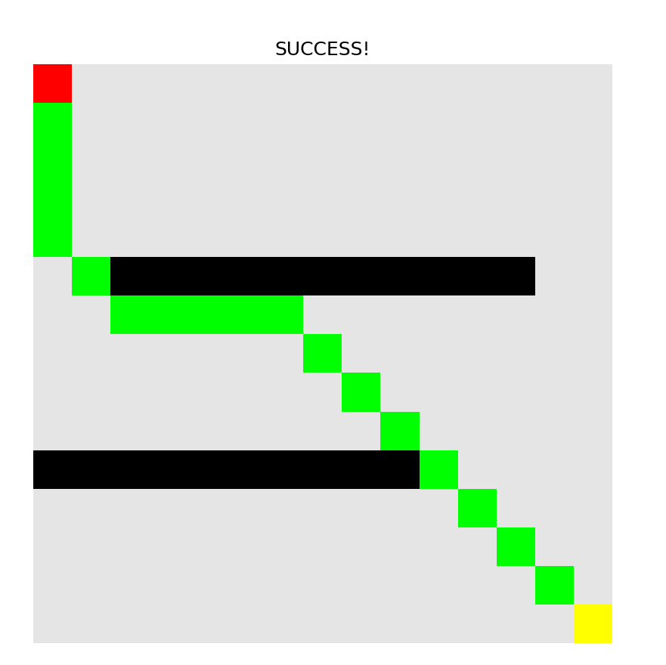
DFS:
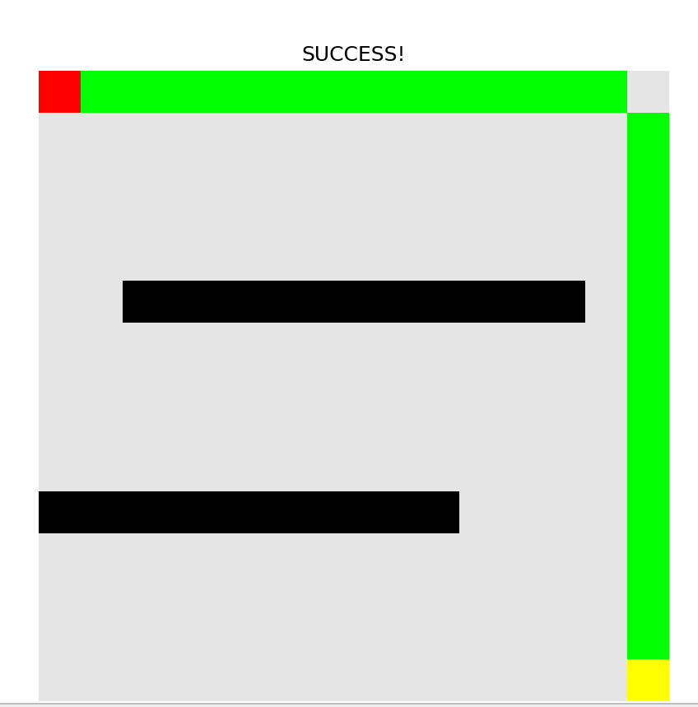
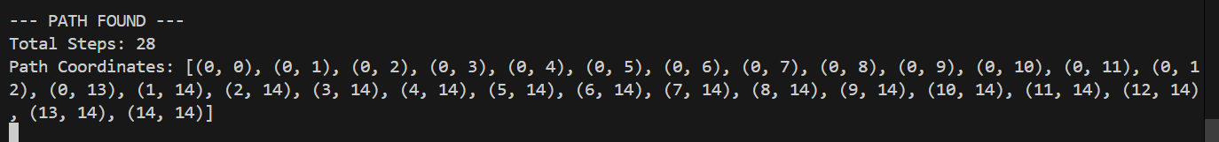
UCS:
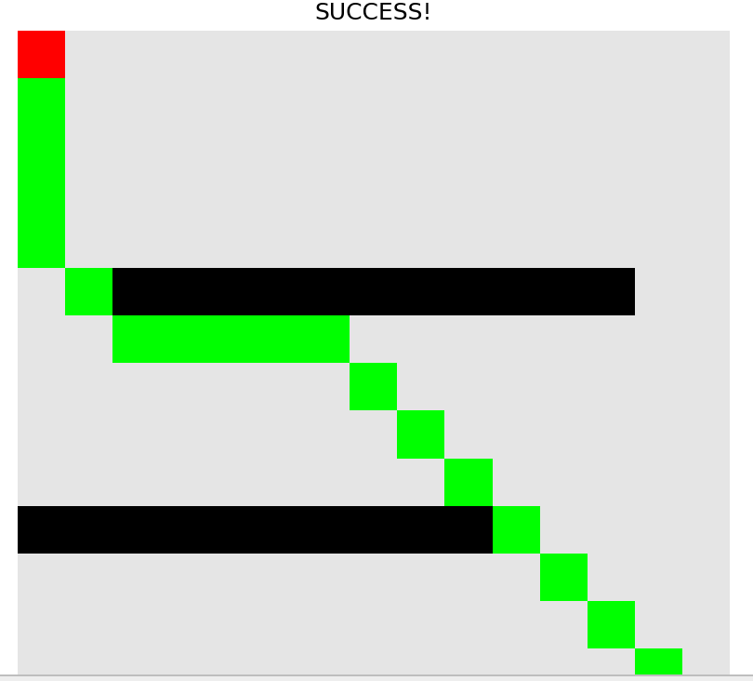
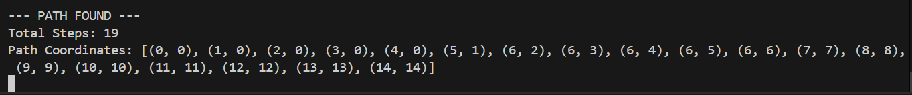
DLS:
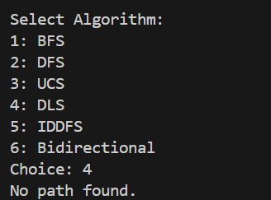
IDDFS:
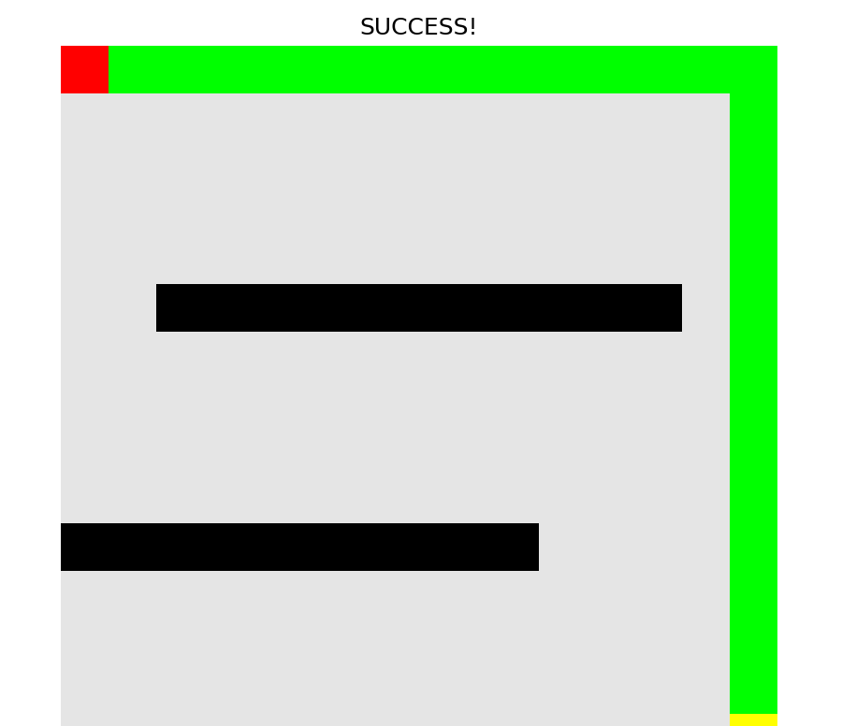
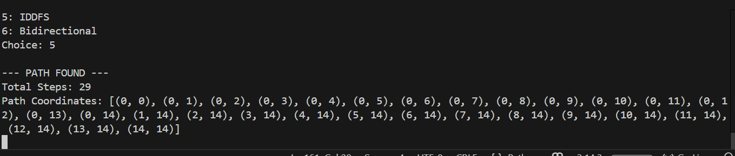
Bidirectional:
